

**Accuracy International Bangladesh**

**Company Profile**

**MESSAGE FROM THE MANAGEMENT**

We warmly welcome you to the arena of Accuracy International Bangladesh. In a nice day of 2016 we started our journey & since then we are trying to contribute to the professional area of Bangladesh by our professional services. We are proud of our service in the area Consultancy, construction, supply of materials and safety and Security.

"Accuracy international Bangladesh l" is a full-service management consulting and field work oriented firm that offers high value business solutions across multiple disciplines and industries. We are a result-driven innovative professional training and learning organization that specialized in customized corporate training. We help your company to improve employee performance, processes and procedure so that your company can grow and secure your customer base in a profitable and sustainable way. We provide consultancy on management, engineering, safety & security solutions. We are ready to supply any goods that you need for the growth of your business.

During the journey we have conducted numbers of training sessions in different organization and institutions. “We prepare your future” the slogan we deserve. We always look for best optimum solution of your problem. The morale and values in all our service area, we not only believe but also practice. We believe in quality training, safe and sound engineering working procedure, quality workmanship & continual efforts R & D. Our professional services with next generation technology will be client worthy with much more momentum in the days come.

We hope you will be with us. We look forward to be of service to your needs.

EngrRtn Lt Col Md. Monwarul Islam, afwc,psc,Peng (Retd)

Chairman, Accuracy International Bangladesh

House #229, Road# 03

DOHS, Mirpur

Dhaka 1216

**Company Overview**

1. With motto “we provide your future”, Accuracy international Bangladesh was founded by group of professional having extensive Technical Knowledge and managerial expertise in Architectural, Civil engineering, education, project management and culture and arts. We have good numbers of Trainer, engineer both Architects &Civil engineer, Accountants and administrative talents. An organogram is in vogue to administer the company smoothly, efficiently, effectively and accurately. The company is committed to provide quality service through effective and efficient management

Accuracy international is established in 27th May 2016 keeping in mind to provide service in the following four major areas:

1. Training and mentoring: We provide training to the employee & management of the corporate. We have about 35 modules to train employee. We provide training to students of Universities to groom them up for professions. We take classes for the students of BBA, MBA, and Civil Engineering. Training that we have already provided to the different organization (Client List) are given in Annexure “A “. Thetopic / module that we can master for you is given in Annexure “B “
2. Consultancy: With a very experienced engineer and management experts we provide consultancy on Architectural, Civil engineering and management including HR consultancy.
3. Construction / Project Management / Supply of Materials: We have number of Civil engineers and project management expertise to look after the construction, handle projects. We have management staff to look after the supply of materials. Some of the client with who we have worked are listed in Annexure “C” and certificate of Completion are attached here with.
4. Safety & Security and Investigation: We have security expert from Defence and Police service to resolve any safety & security of any company. You may also explore our expertise for investigation of any irregularities within your organization.

2. We are working collaboratively with our clients to achieve the best possible result. We like to embark on a platform where fusion of professionalism, quality & economy prevail. Wedesire to earn acme of reputation by providing high quality, cost effective technological and efficient superior solution to all our service area.

3. We aim to cover legendary customer service by blending quality service with cost effective solution to every sector of our service with marginal time frame. We appreciate your trust and we will be always careful about your opinion. We believe that this is the reason, that’s why you can rely on us at any time.

**Legal Status of Accuracy International Bangladesh**

**Name of the Company: Accuracy International Bangladesh.**

**Type of Company**: Ownership.

**Trade License No**. 02-29247, Dhaka North City Corporation, Dhaka (Attached)

**VAT No**. 17021041060 (Area Code 170102) (Attached)

**Tax Identification Number**: 285393899768 (Tax Circle: 190, Tax Zone 09 Dhaka), (Attached)

**Bank with: Account No** 0002-0210135396(Savings) Trust Bank, Dhaka Cantonment Corporate Branch.

**Date of Start of Business**: 18th July 2016

**Our Logo:**



**Vision:** Promise in achieving accuracy in the servicesthat the company is offering and to encourage the customers to pursue accuracy in all aspect of their life

**Mission:** We work in the area of construction, consultancy (engineering management and HR), training, coaching, security, investigation and we want to be the accurate in all aspect to be number one where ever we are.

Our Values:

* Customer satisfaction
* Ethical business
* Integrity
* Trust worthiness

**Short Biography of Proprietor of “Accuracy International Bangladesh**

**EngrLieutenant Colonel MD.Monwarul Islam afwc, psc, PEng, FIEB**

MSc (BUET), MBA(HRM)MWS, MDS

1.**Educational Qualification:**

|  |  |  |  |  |
| --- | --- | --- | --- | --- |
| Degree | Institution | Year | Main Subjects | Result |
| MSC( Civil Engineering) | BUET | 2004 | Soil mechanics, Earthquake, Transportation, Aquatic chemistry, Advance concrete etc | CGPA 3.19 |
| MDS  (Masters in defense studies) | National University | 2004 | Geo Strategic management and studies, National security, command and leadership | 2nd Class |
| MBA | RoyalUniversity , NationalUniversity, Dhaka | 2006 | Major HRM | CGPA 3.8 |
| MWS(Masters in War Studies) | National University | 2007 | Strategy, Command and Leadership at strategic level, Logistics at strategic level, Resource Management, National and International affairs | 2nd Class |
| Post Graduate Diploma in Industrial Management | Bangladesh Institute of Management | 2019 | Cost Accounting, Managerial economics, Industrial Management, HRM, Labor Law, Quantitative management, Occupational health and safety, Basic accounting and production and operation management | A |
| Post Graduate Diploma in Engineering | Military Engineering University ,Nanjing , China |  | Bridging, Bomb Disposal, Mining& demolition, Camouflage |  |

**Courses under United Nations**

Mr. Monwar has undergone following courses for a duration of 6 months and were performed under United nation. The certification was given by the UN training headquarters

* Peace keeping and conflict resolution
* Operational logistics (intermediate)
* Operational logistics (intermediate and advanced)
* Mine action: humanitarian impact, technical aspect and global initiative
* Logistics support to UN peace keeping operation

**Professional Experience:** Col.

* He has Varied and rich professional experience of over 39 years in the field of instructions / training, command & leadership, civil engineering project management, administration, logistic, security, disaster management, bomb disposal and de-mining in Asia, Europe and Africa.
* Served as Associate professor at Military Institute of Science and Technology (MIST). and senior instructor in the school of military engineering for long time.
* Apart from the above Mr. Monwar served as faculty member in many private universities and also involved as part time trainer and consultant.
* He has served in 3 United nation mission in management position where he has proved to outstanding performer.
* As a project director of three different difficult and nation value project (Cox’s Bazar – Teknaf marine drive road, Chimbuk – Thanchi Road along the heights ridge in the chattagram hill tracts, Masalong – Sajek Road project).
* After retirement from Army, He has served in the senior management position in many large conglomerate in Bangladesh both in engineering and HRM; like Palmal Group, Opex and Sinha group, Rupayan Housing estate, OEKOTEX Group etc.
* Presently providing consultancy and training to employees of different organization both in engineering and management.

**The Team Members of Accuracy International Bangladesh**

1. Architect Shah Altaf.

BSc in Architecture (BUET)

1. Engr. Lt Col Md. MonwarulIslam,afwc,psc, Peng(Retd)

Proprietor and CEO

M Sc. In Engg (Civil), FIEB, MBA(HRM), MDS,MWS

1. Engr Mohammad Shamol Khan

Project Engineer (Project Implementation)

B Sc in Civil Engineering (CHUET)

1. Kamrul Hassan

Project implementation Engineer

B Sc in Civil engineering(KUET)(M- 33981)

1. Ms Sayda Sultana

Head of Finance and Administration

M com (accounting , MBA

1. Mr. ShihabMithun

Asst Engineer ,Electrical

B Sc in EEE

1. Md. Kamruzzaman

Assistant Engineer and AUTOCAD Operator

Diploma in Civil Engineering.

Nougaon Polytechnic

1. Ms. MonishaMonwar

Manager Marketing and customer service

BA Honors (Media and Mass Communication)

1. W/O Sarwar(Ex Army warrant Officer)

Supervisor

1. Sgt Hakim

Supervisor

**Construction Equipment’s That We Hold**

1. Mixture Machine : 03 (one with hopper)
2. Movable Generator (12 KVA) : 01
3. Vibrator Machine : 06
4. Roof Hoist : 01
5. Welding Machine : 01
6. Different types of Water Pumps : 05
7. Rod cutter : 06
8. Moveable Electricity Supply : Electric wire (500m), Electric switch Board and others
9. Hammer Drilling Machine : 01
10. Hand Drilling Machine : 03
11. Spade : 10
12. Belcha : 12
13. Hammer (Different types) : 10
14. Shovels : 07
15. Steel Measuring Tape (10m) : 08 :
16. Steel Measuring Tape (30m) : 04
17. Steel Sutter : about 100 SqM
18. All other necessary construction tools

**Note:**Accuracy international has capacity to make available heavy equipment likeScavator, Roller, Dump Track, Crane etc. at construction sites within least possible time.

Annexure “A”

Training Activity and Client List

* Robi Axieta
* Crown Cement
* BBS
* Bank Asia
* AB Bank
* Nitol Motors
* Trust bank
* Dhaka Bank
* Design Solution Centre
* Karl Venz Automobile
* Heaven tours and Travel
* Trainer of Rapport Bangladesh
* Trainer of Skill Shop
* Panel trainer of Chakri.com
* BSHARP Panelist
* PSB panelist
* Trainer at BIM
* Bangladesh University of Professional, Mirpur Cantt, Dhaka
* National Institute of Biotech, Savar , Dhaka
* Swift Solution
* Begum Rokeya University, Rangpur
* Icon Group
* Sajid properties
* KAFCO
* BOLD
* Shristy Construction

Annexure “B”

We Can Master These Topics and Excel Ourselves Best Way to Grow the Company and Grow yourselves

|  |  |  |  |
| --- | --- | --- | --- |
| Serial No | Topics | Target group | Remarks |
| 1 | Anger Management | All level |  |
| 2 | Achieving Excellence | All level |  |
| 3 | Balancing Work and Life | All level |  |
| 4 | Competency Approach to HRD/ Competency of Manager | All Level |  |
| 5 | Communication Skill | All level |  |
| 6 | Communication Clearly | All level |  |
| 7 | Conflict Management | Mid to Top level |  |
| 8 | Crisis Management | All level |  |
| 9 | Customer Service | Field to Mid level |  |
| 10 | Effective Leadership | All level |  |
| 11 | Function of HRM | Field to Mid level |  |
| 12 | Handling Boss | Field to Mid level |  |
| 13 | Handling Grievances | Field to Mid level |  |
| 14 | How to Delegate | All level |  |
| 15 | Interview Skill | Mid to Top level |  |
| 16 | Influencing people | All level |  |
| 17 | Making presentation | All level |  |
| 18 | Managing Team | All level |  |
| 19 | Managing Change | All level |  |
| 20 | Managing People | All level |  |
| 21 | Managing Conflict | All level |  |
| 22 | Managing Your Time | All level |  |
| 23 | Motivating People | All level |  |
| 24 | Marketing Effectively | Field to Mid level |  |
| 25 | Negotiation Skill | All level |  |
| 26 | Professional Etiquette | All level |  |
| 27 | Report Writing | Field to Mid level |  |
| 28 | Risk Management | Field to Mid level |  |
| 29 | Safety and Health Management | Field to Mid level |  |
| 30 | Selling Successfully/ Selling Skill | Field to Mid level |  |
| 31 | Stress Management | All level |  |
| 32 | Team Building | Field to Mid level |  |
| 33 | Thinking Creatively | Field to Mid level |  |
| 34 | TQM/ 6 Sigma | Field to Mid level |  |
| 35 | Operational Excellence | Mid to senior level |  |

Annexure “C”

The client List on Supply

1. Sristhy Construction
2. Sheba XYZ
3. Shah Altaf and Associates
4. M/S H A enterprise
5. Rigel Energy Limited

**Some Pictorial Overview of Our Training Program**

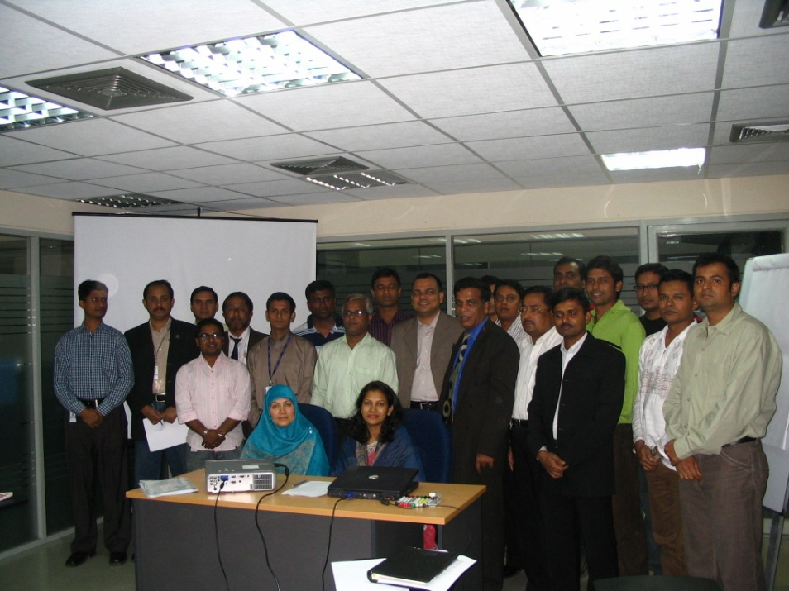

Presentation on Professional etiquette At Robi

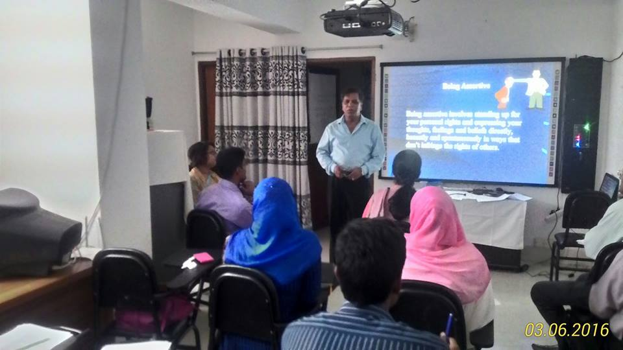

Presentation at Accuracy International on Stress Management on 3rd June 16

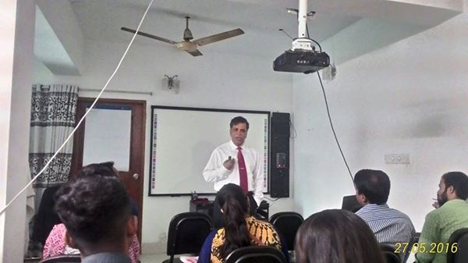

Presentation on Interview Skill at Accuracy International Bangladesh 27th May 16

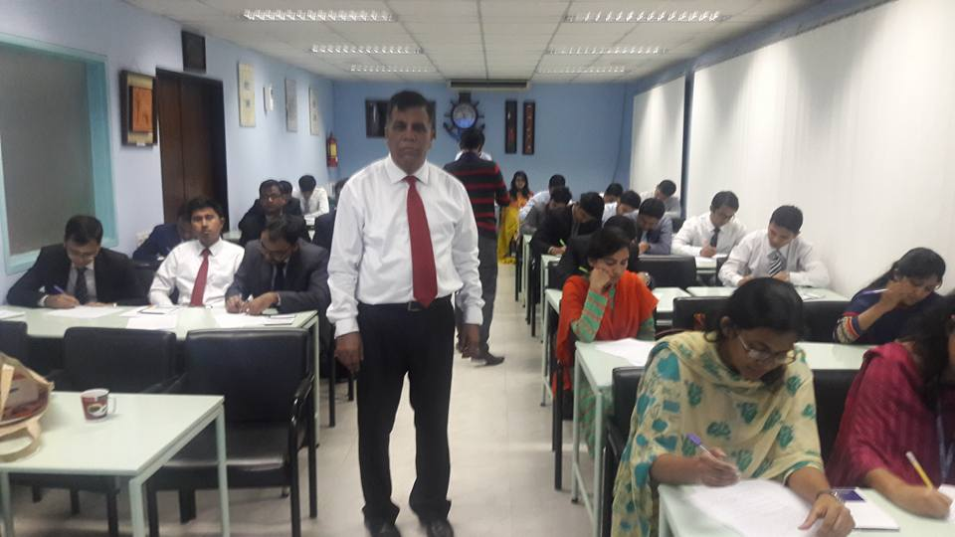

Presentation on Professional etiquette at Dhaka Bank on 31 January 17

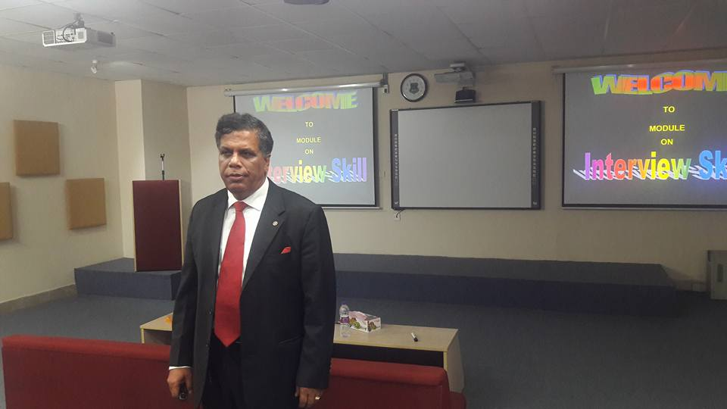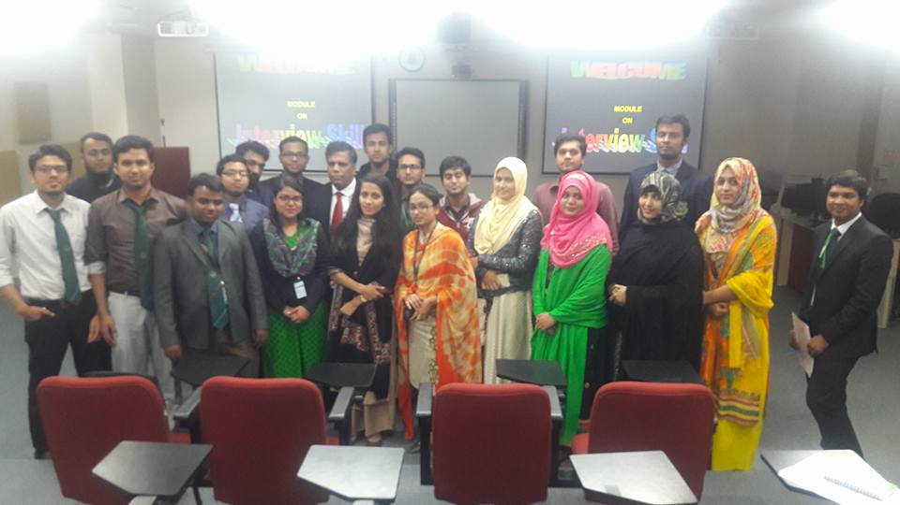

Presentation on Interview skill at Bangladesh University of professionals 31 Jan 17

Interact Club

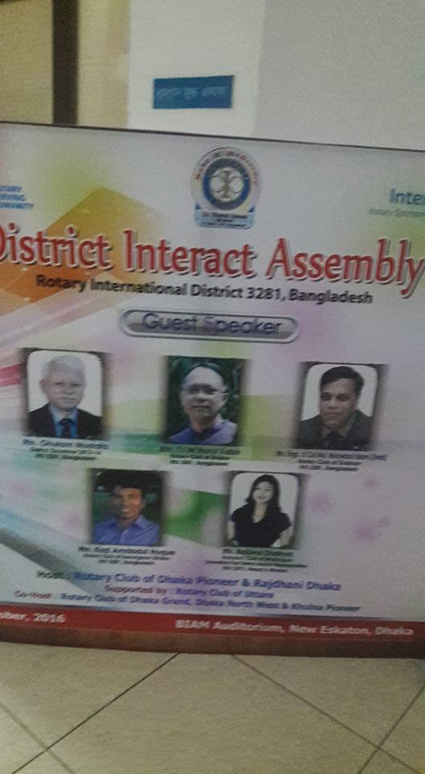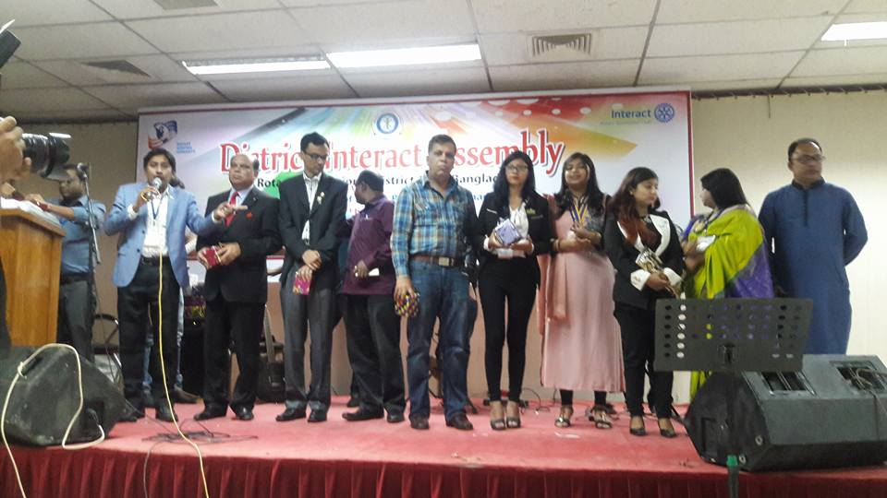

Presentation on motivation for The Interact Clubs at BIAM Dec 16

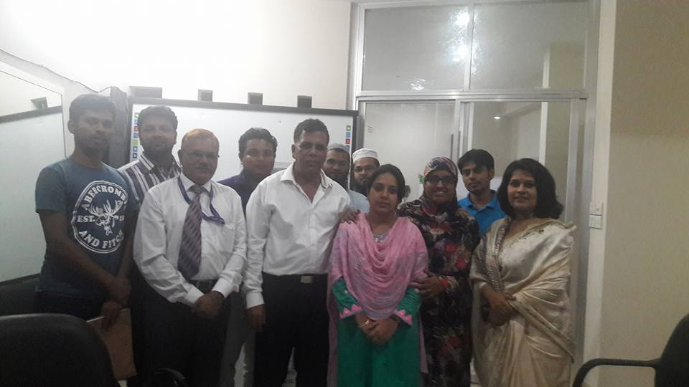

Time management at AIB 17 oct 16

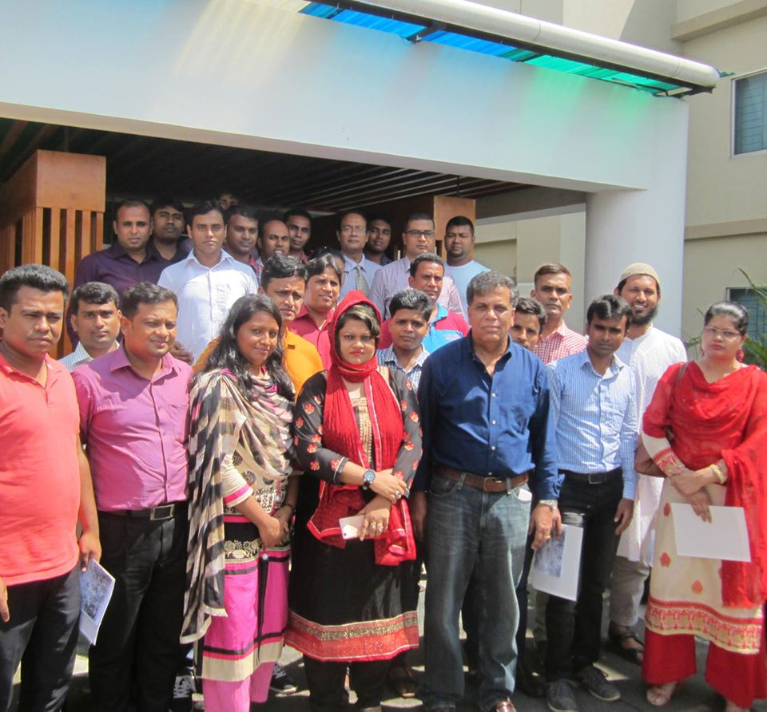

Training session on Time management organized by BSHARP on 4th Oct 16

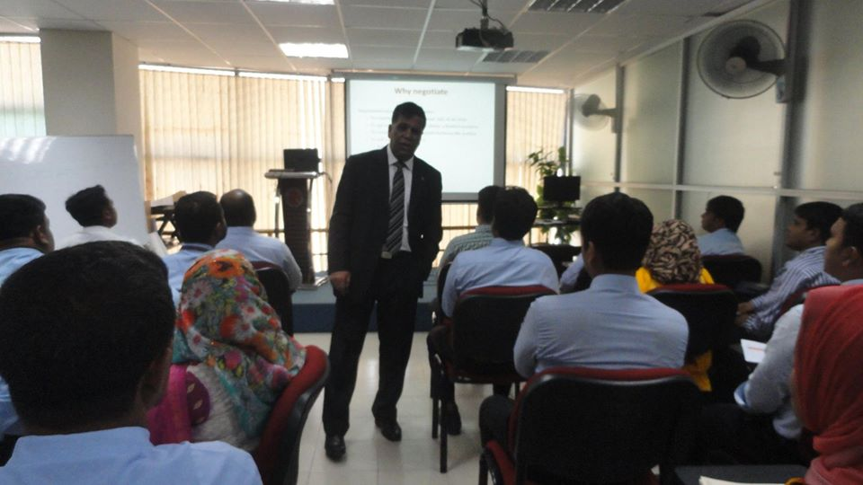

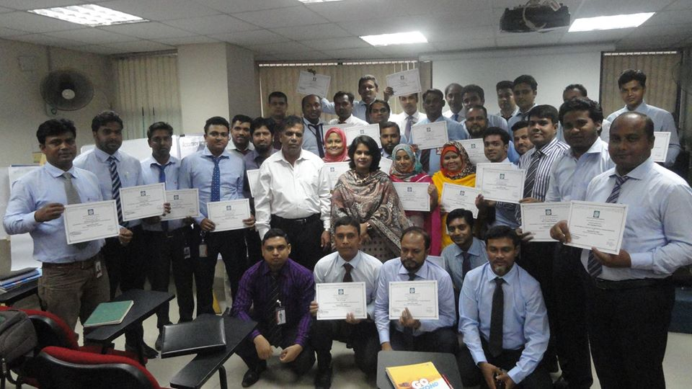

Training session on Negotiation skill at Nitol motors 31 Dec 16

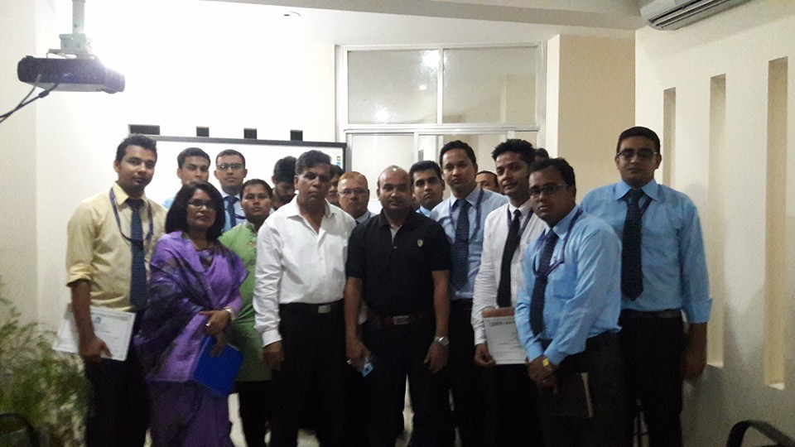

Training session on Professional etiquette at AIB, 24 Sep 16

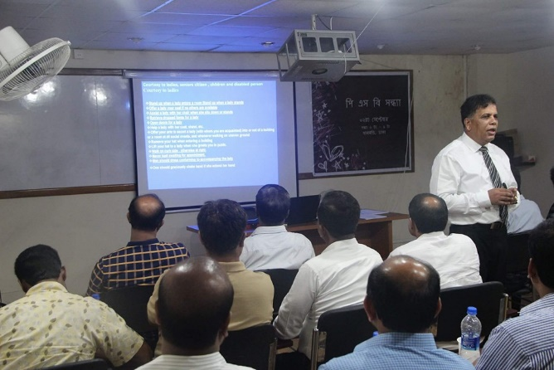

Professional etiquette at AIB, 6 Sep 16

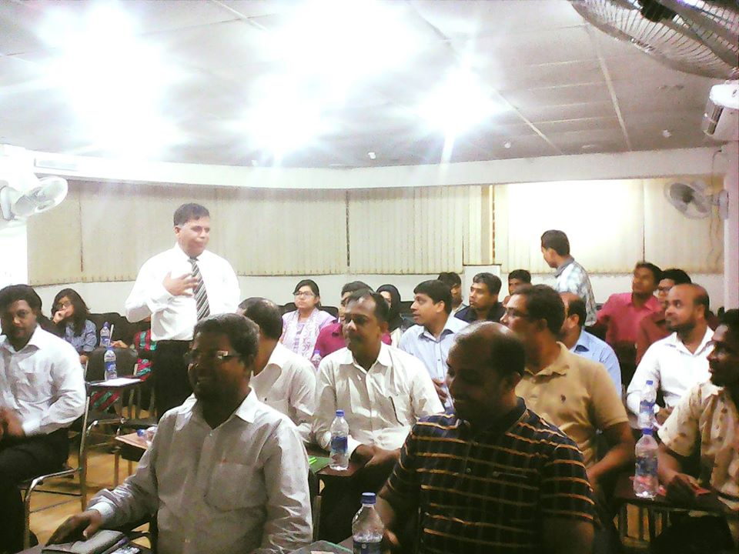

Training session on Professional etiquette2nd Sep 16

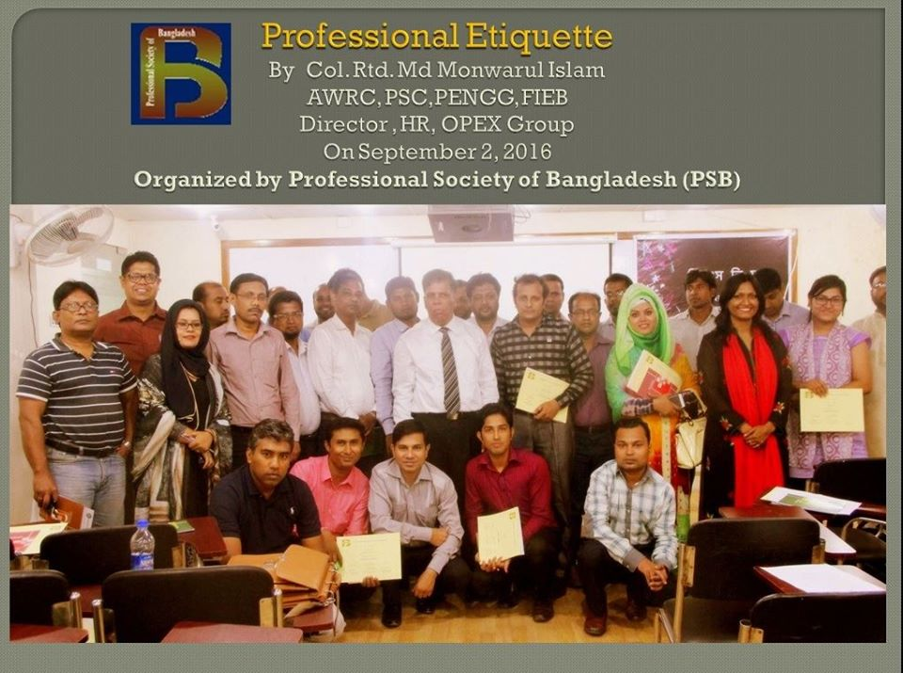

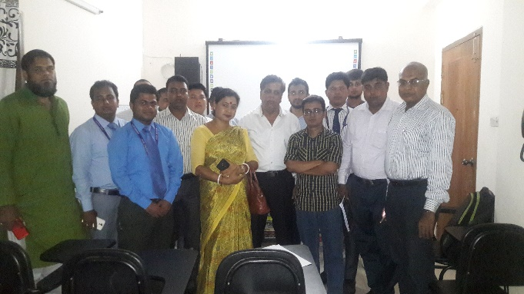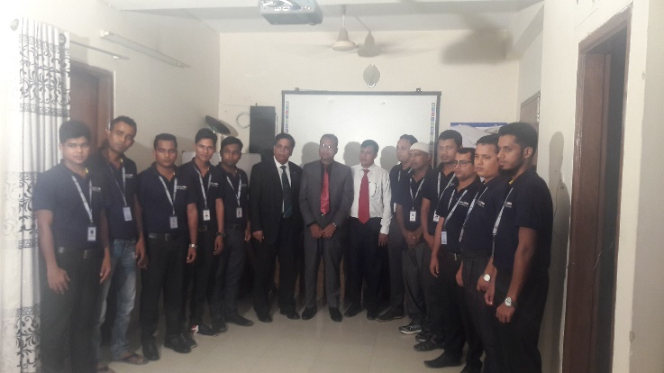

Training on stress management at Accuracy Training on Operational excellence at AIB for

International on Stress management Real-estate

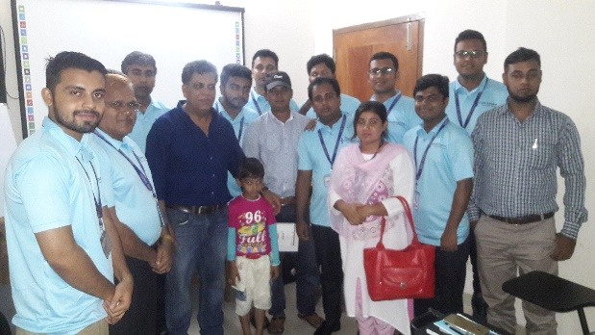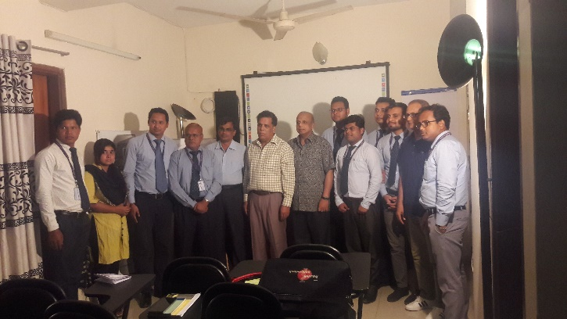

Training Communication skill at AIB Training on Team Building at AIB

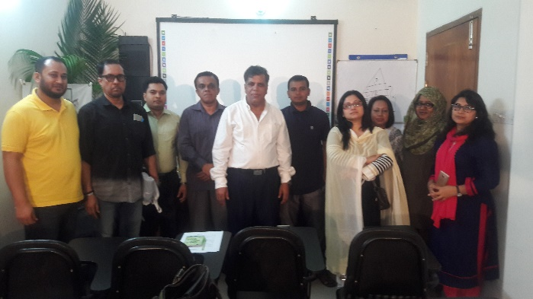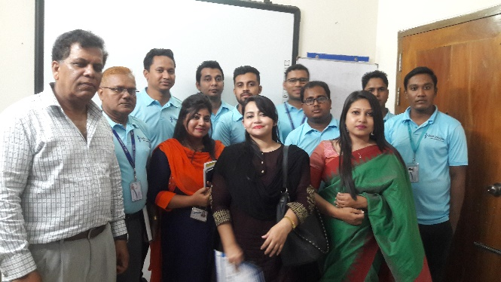

Training on Anger Management at AIB Training on Leadership at AIB

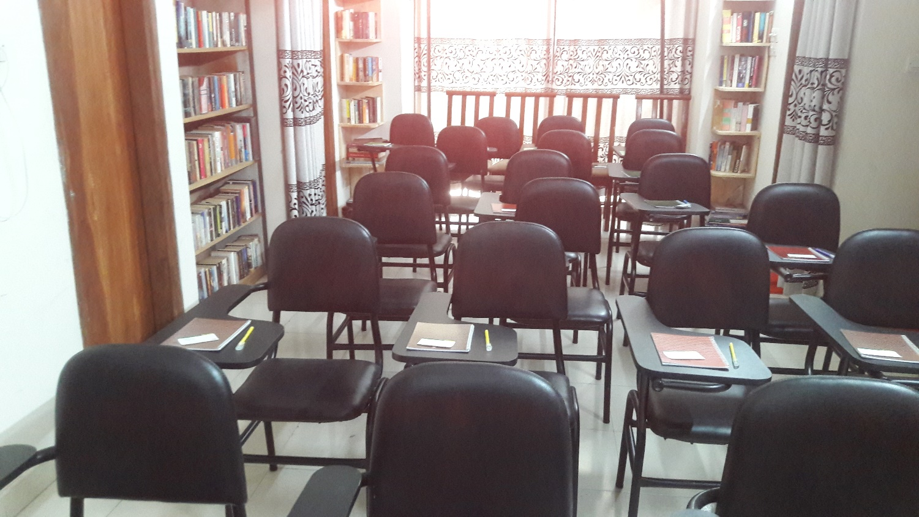

Over view of the Accuracy International Class Room

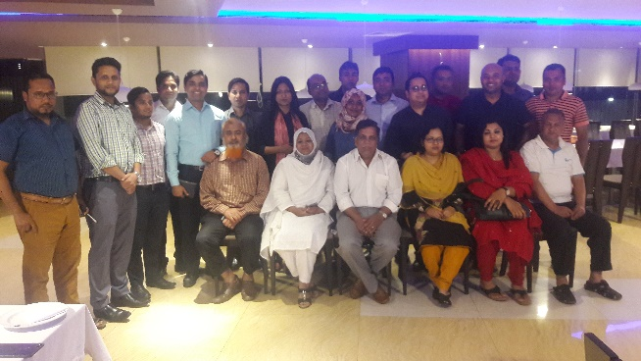

Training on Stress Management followed by Dinner at RAOWA

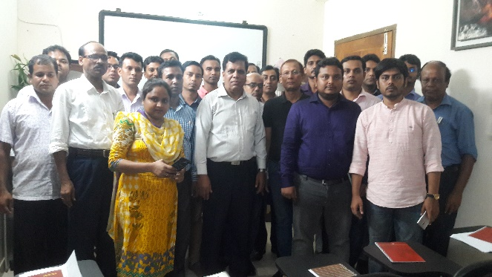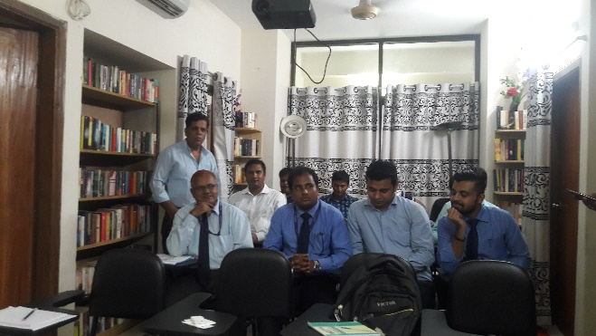

Training on Professional etiquette at AIB Training on customer Service for Swift solution

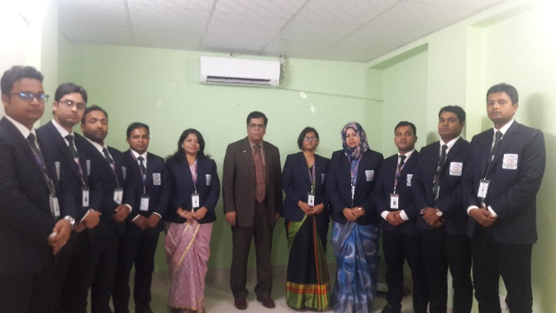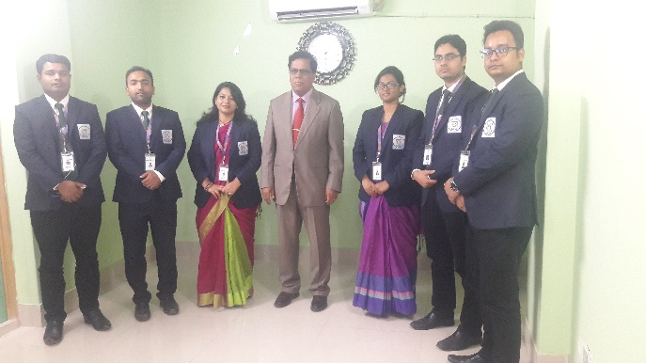

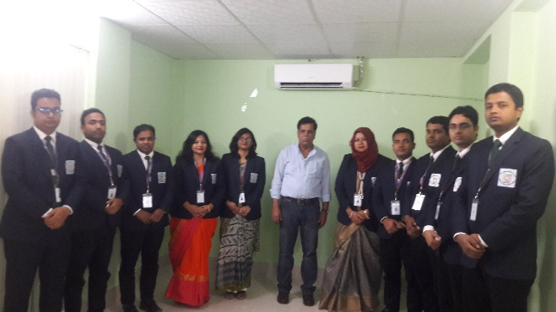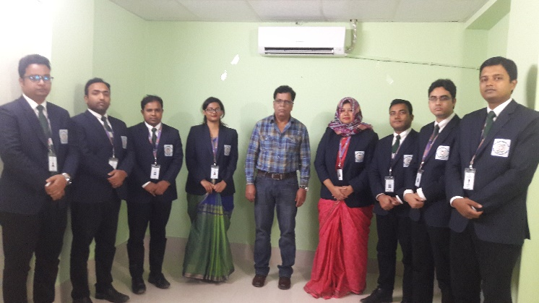

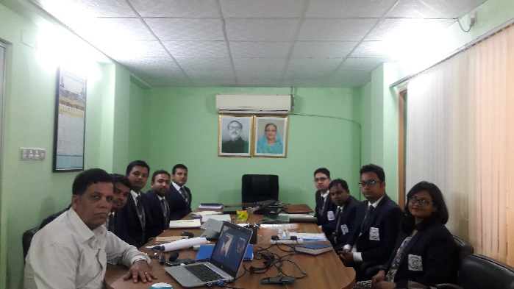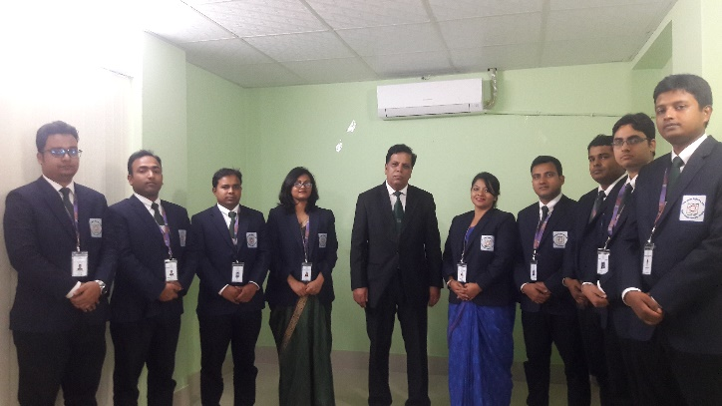

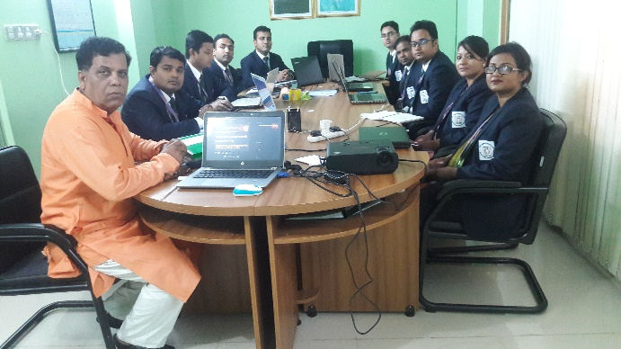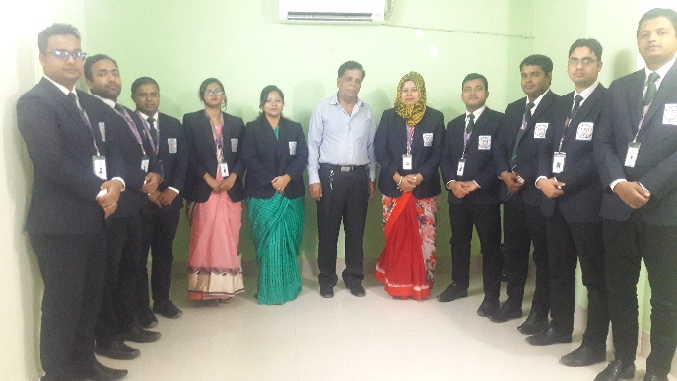

Training on professional grooming, stress management, time management, anger management, operational excellence, leadership, motivation, time management, operational management, basics of Human resource, presentation skill, communicate clearly for six months on a foundation course for the faculty member of Begum Rokeya University conducted by me.

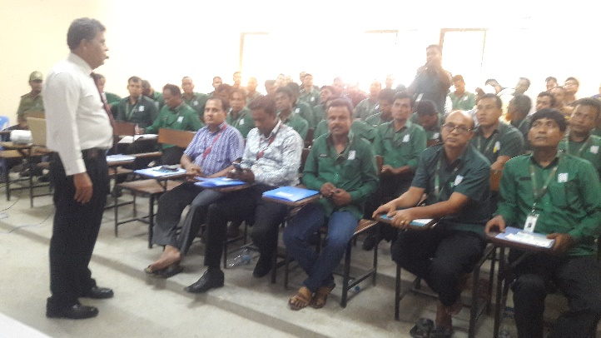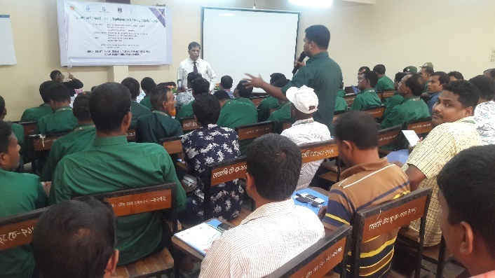

Training on Service Rules and regulation for guard of Begum Rokeya University

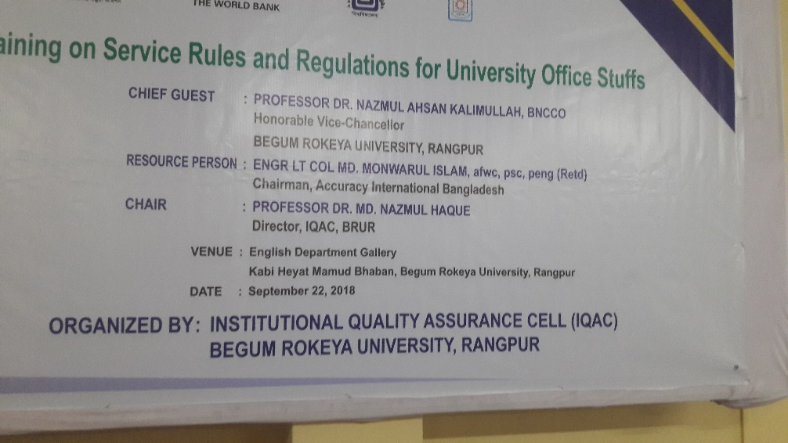

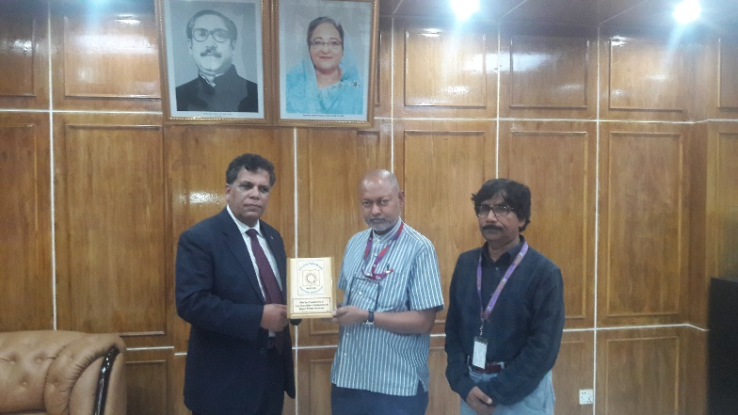

Receiving crest after the session from the vice chancellor of Begum Rokeya University



**Date: 10 January, 2021**

To,

Director General (BD-4)

Sena Kalyan Sangstha

SKS Tower (11th Floor)

7, VIP Road, Mohakhali, Dhaka-1206.

Sub: Submission of Documents.

Reff:

A: 20201006101

Sir,

In relation to the refence” A” and our offer for supply dated 06 Oct 2020 Please do find the related documents for your further information and action. Documents that are provided are listed below:

* 1. Company profile
  2. Up to Date trade license
  3. Work experience certificate
  4. TIN certificate
  5. VAT Certificate
  6. Up to date Tax return copy
  7. Birth certificate
  8. Character certificate
  9. NID

Appreciate your understanding and Regards

Sincerely Your

Engr Lt Col Md. Monwarul Islam,awc,psc,Peng (Retd)

Proprietor

Accuracy International Bangladesh